```Mask-Afr-Mali-Djenne-Male head

**Djenné and the 2013 plight of historical works of art in Mali**

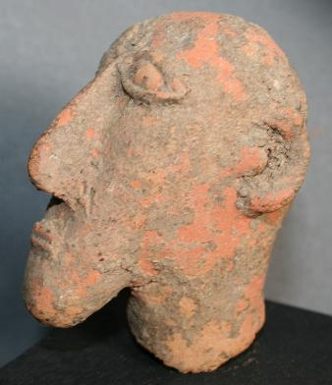 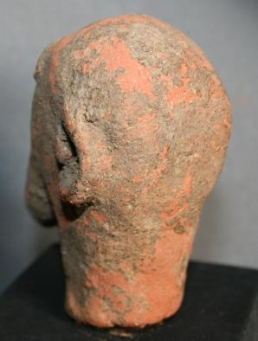

This very rare terracotta head of a male with Semitic features dates to the 14th-15th centuries when Arab traders were traveling caravan routes across the Sahara desert to the trading areas of west Africa along the Niger River. This terracotta was excavated in Djenné which houses an ancient Mosque that dates to the 14th century as well and this individual, who was of high rank, may have been one of the leaders who was responsible for the building of the Mosque.

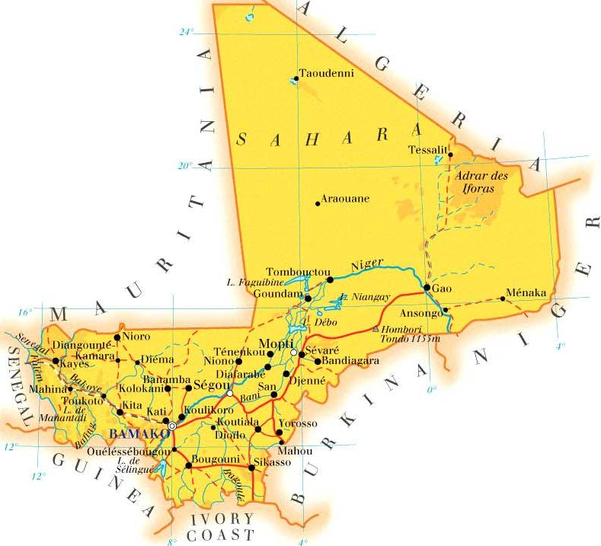

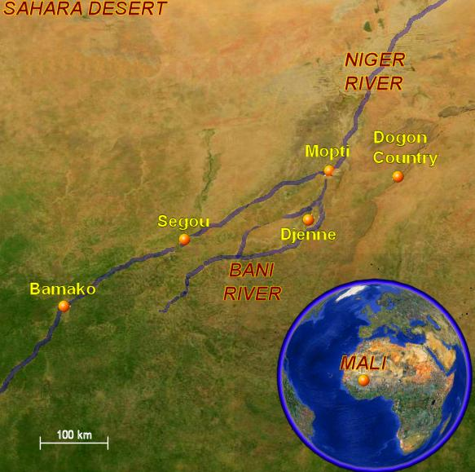

### Earth works

What’s more, though the mosque at Djenné and other celebrated mud buildings are part of long traditions and ancient cultures, this method of construction is not confined to the past. In recent years, vernacular construction techniques and the use of natural materials have been experiencing a global resurgence, as people seek more sustainable and low-cost approaches.

Not far from Djenné is Timbuktu, the last outpost before the Sahara Desert. Despite the city’s remote location, it boasts a rich heritage of scholarship that has produced a wealth of manuscripts – and South African firm dhk Architects was recently given the task of designing a library to house 20,000 manuscripts and reference materials. Introducing a fitting building for the low-tech, mud-built setting of Timbuktu was a challenge the firm responded to by employing a hybrid of traditional and contemporary styles. The result is a 50,000 square-foot building constructed primarily with mud, which, like the Djenné mosque, requires maintenance after the annual rains. To provide additional protection for the archive and conservation lab, standard concrete-block cavity walls were also introduced.

With the insurgence of the radical Muslim AGIM in Mali in January 2013, the plight of the manuscripts was saved by local people who transported the manuscripts in burlap bags down the Niger River to safety in Burkina Faso.

